34.86: a) 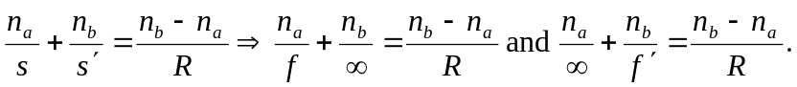
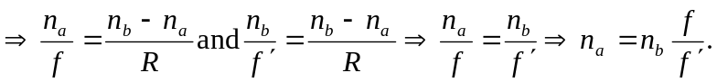
b)
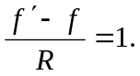
Note that the first two equations on the second line can be rewritten as 